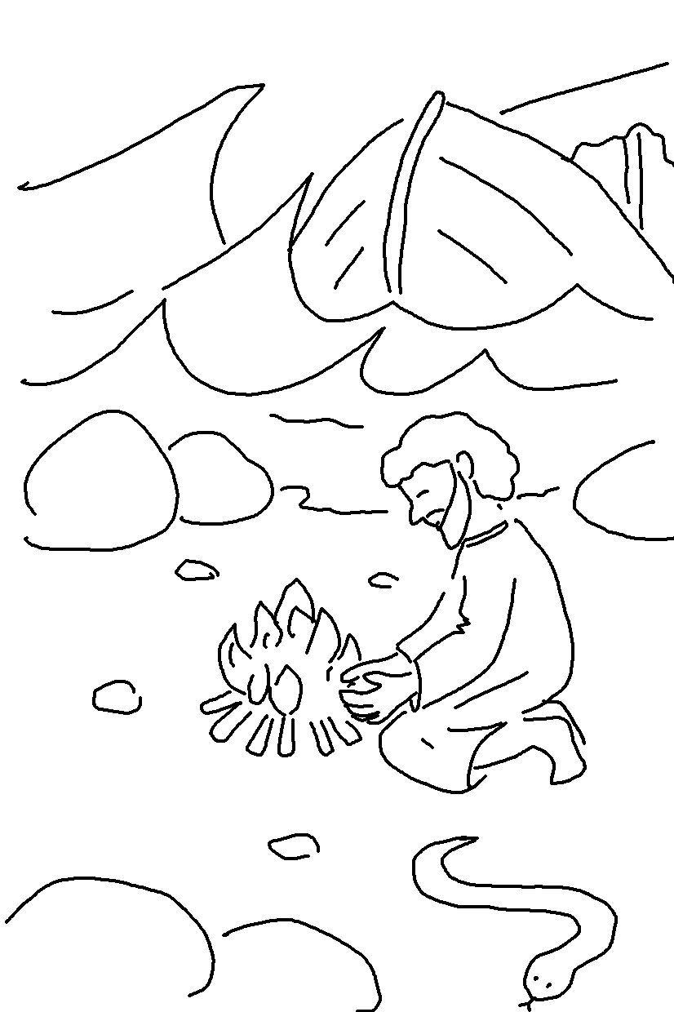
The Lord hears His people when they call to Him for help. Psalms 34:17_{NLT}

